Gritplan

["Glock right plan – Define words properly – Not 100%R – More like thoughts"](https://wordpress.com/post/gritplan.wordpress.com/524)

## [BAD TIMES PAY ATTENTION](https://gritplan.wordpress.com/2024/05/21/bad-times-pay-attention/)

Posted on [May 21, 2024](https://gritplan.wordpress.com/2024/05/21/bad-times-pay-attention/)

Here is something i uncovered about torture thieves that roam are society. In reality I believe they are not thieves but rather someone who watch over like a god would, helping and hurting you. The reason I stayed with label torture thieves is because by studying the label you can uncover a lot which can help you avoid trouble and achieve more.

Torture Thieves  
T or true returns hills e vanishes  
T or true returns hive e vanishes  
T or true returns half in evolutions extras  
reveals thing earn  
reveals think earn  
Reveals think develop s (ad se)  
Dirty evil Engulfed over (rise and soar or store)  
inhabit in half big test – means don’t get “ha not that one” instead get “gets a life” from a judge, jury or torture thief referring to the word half split in half as two polar opposites, ha and life.  
Lose being earths statue – Do good in the half test, has perks of being a whole lot more than those that avoid their dues who might end up in places that are dark and dusty.   
Watch connect tu a real night – Don’t con your neck and watch getting hot  
Your neck of the woods  
Iam hangin out on a limb for you  
Watch caffeine or also make same use of non caffeine or earn in test rejection. Lime is important too. Simple things can change verdicts in the half test like your care to caffeine or non caffeine.

Pay attention to evolutions ego dealer or got rid of three

Get overtime rights decide off, t hour double off

Operate gamer t-time test, deal off, insist tide city or tide cities made off

[Edit](https://wordpress.com/post/gritplan.wordpress.com/1250)

["Bad times pay attention"](https://wordpress.com/post/gritplan.wordpress.com/1250)

## [THE DYNAMIC OF MY HELP HAS CHANGED. EVERYTHING CREATED, AFTER THIS POST, I CREDIT MY DIRECT FAMILY AND ME SOLEY, UNLESS I GET HELP. MY TEACHINGS FROM MY SOURCES CAN ALSO BE CREDITED IN SOME WAY AS WELL. I WILL PROPERLY CREDIT ALL HELP I GET.](https://gritplan.wordpress.com/2024/04/25/everything-created-after-this-post-i-credit-my-direct-family-and-me-soley-unless-i-get-help/)

Posted on [April 25, 2024](https://gritplan.wordpress.com/2024/04/25/everything-created-after-this-post-i-credit-my-direct-family-and-me-soley-unless-i-get-help/)

Everything took a wrong turn and I have stopped posting for over a year. The future of the site is coming as my main focus is building gpa’s (Gritplan accounts). I want gpa’s to integrate in a persons life as tool to better equip you for the world.

Here is some of my plans for gritplan.com

Create groups and communities so you can work on your plans within them.

Include goal building and problem addressing in your gpa(Gritplan account)

Work with AI to allow instant plan building

Create a way for plans to be sold

Create a live feed for all incoming public plans

[1 Comment](https://gritplan.wordpress.com/2024/04/25/everything-created-after-this-post-i-credit-my-direct-family-and-me-soley-unless-i-get-help/#comments)[Edit](https://wordpress.com/post/gritplan.wordpress.com/1201)

["The dynamic of my help has changed. Everything created, after this post, I credit my direct family and me soley, unless I get help. My teachings from my sources can also be credited in some way as well. I will properly credit all help I get."](https://wordpress.com/post/gritplan.wordpress.com/1201)

## [HOW TO HAVE/EARN UNLIMITED, LIMITLESS, NEVER-ENDING, EVERLASTING, FOREVER, ENDLESS, INFINITY AND ETERNITY .](https://gritplan.wordpress.com/2023/02/20/how-to-have-earn-unlimited-limitless-never-ending-everlasting-forever-and-endless/)

Posted on [February 20, 2023](https://gritplan.wordpress.com/2023/02/20/how-to-have-earn-unlimited-limitless-never-ending-everlasting-forever-and-endless/)

Remember these are unproven. To begin you must have a try all mindset when dealing with anything. Then you must define the forever opportunities, there could be more, as related to tanks that never runs out of gas under your own definitions or for the time being borrow someones else definitions. Then memorize somehow the terms and forgot about knowing any definitions word for word unless you want, see a need to. For example my definitions in my own words are as follows.

All our unproven completely

Unlimited – Not defined by any boundaries regarding it limits.

Limitless – Has a limit with a never-ending supply

Never – ending – Having no ends, or no beginning possibly. Possibly goes on indefinitely.

Everlasting – Runs forever and doesn’t end

Forever – Has an ending that is to an end that doesn’t stop

Endless – Has an end with a never-ending supply

Infinity –

Eternity –

Eternal –

Evermore –

This can come handy when you need, want to produce more than you have of something important.

To produce something important take precautions and do not set up limits. Create an up version to be mobile. Generate code to make work expandable. Create generating spots to harbor work.

[Edit](https://wordpress.com/post/gritplan.wordpress.com/1017)

["How to have/earn unlimited, limitless, never-ending, everlasting, forever, endless, infinity and eternity ."](https://wordpress.com/post/gritplan.wordpress.com/1017)

## [WHEN YOU CONNECT PIECES OF ART WITH MATH USING SINGLE OR MULTIPLE RELATORS, YOU CREATE SHINING PATHWAYS THAT CAN BE UTILIZED DAILY TO ASSIST WITH LIFE PROBLEMS, SUPPLYING HEALTH OR ART GENERATION FOR THE EYE NEEDY.](https://gritplan.wordpress.com/2023/02/20/when-you-connect-pieces-of-art-with-math-using-single-or-multiple-relators-you-create-shining-pathways-that-can-be-utilized-daily-to-assist-with-life-problems-supplying-health-or-art-generation-for/)

Posted on [February 20, 2023](https://gritplan.wordpress.com/2023/02/20/when-you-connect-pieces-of-art-with-math-using-single-or-multiple-relators-you-create-shining-pathways-that-can-be-utilized-daily-to-assist-with-life-problems-supplying-health-or-art-generation-for/)

If art from an independent graphic designer is connected with circle region mapping, possibilities open up for creating targeted energy hotspots and finding out which regions globally receive the highest connections to the sun naturally (creating shareable outdoor solar regions for the needy) that can be connected with an app to provide constant fast solar charging (electronic software communicates better with a a battery since they’re massive amounts working daily internally, externally to provide needs which are already tested) (Within seconds to minutes if done right for a high capacity battery) to increasing experimental plant growth. The logic is a sphere generating energy for another sphere tend to share similar qualities even when miles away that connect easily using relators.

Current concept – shareable solar spots

[Edit](https://wordpress.com/post/gritplan.wordpress.com/1014)

["When you connect pieces of art with math using single or multiple relators, you create shining pathways that can be utilized daily to assist with life problems, supplying health or art generation for the eye needy."](https://wordpress.com/post/gritplan.wordpress.com/1014)

## [CONNECTED MATH ART OR PYRAMID TEETH IDEA](https://gritplan.wordpress.com/2023/02/03/pyramid-teeth-idea/)

Posted on [February 3, 2023](https://gritplan.wordpress.com/2023/02/03/pyramid-teeth-idea/)

This is the possibility of something, anything is possible.

Pros and cons of article/plan

Pros:

Animals and humans with tooth/teeth needs get a chance to read it indirectly. I am not defining all numbers just abstracting a few that are critical to all at the moment, due to our times.

Cons:

Not the right time possibly. People may view it as defining numbers in minor points. Opens the door to new math concepts not previously taught which can be unproven

If you understand the above pros, then get ready for a concept that in the 4th millennium (3001-4000) should make everyone throw in their 2 cents due to the advancement of the brain and teeth with the personal benefits connected math art has.

Its starts with 3 and mass, then comes math and drive.

The security is defined by a master key and a safe space, that connect form to form. Its like connecting different rooms together with each having a distinct design to form your teeth backed by earth.

With 3, choose more numbers so you can reach 32 and make a number set that you can use to multiply, divide, add but not subtract. The number set must be organized by the order in which you want your math to flow. Make your own further rules or use created ones.

An example is 3 ,5,2. The last two numerals of your choice must multiply and divide by 2 properly.

This is because the last part of your number set must breakdown and regenerate correctly so when passed through different stages of math can replicate this trait at least half the time. This is a goal and has no proof yet.

Multiply the first number by the last to temporarily replace 3 with 6 in this case. So the number set becomes 6 ,5,2. Then multiply 6 by 5 which results in 30 and add 2 reaches you 32 safely.

Now you must come back from 32 back to one not none, 3 characters not 4, and you want to not subtract at all ever. Also reaching no-one brings back nothing. I like to use the original number set, since technically 32 contains the numbers 3 and 2 and 3 + 2 = 5, you can recall or reproduce 3 and 2 once you created 5. Now use a equalateral triangle with the number set master keying the outer angles. 3 is placed at the bottom left, 5 is placed at the top and 2 is placed at the bottom right. The flow is go up by 2, down by 3 and left by plus 1. When triangulated it goes left by plus 1 up 2 down 3. Then you can go up 3, down 2 and right by plus 1. Thats it. You worked to make 32 and come back to 1 via triangles and without subtracting.

Now thank all triangles for your endless building teeth and find a supplier for white, possibly brown minerals. Unproven obviously.

Next come safe spaces or your defense against destruction which should be a secret even to you.

Pyramids may share their roots with you possibly. Send a card maybe.

End achievement you do not go in four directions, rather 3 rotations.

If you look below to the right sequentially at the numbers being added you can see if you group it in 2’s 32 is the only number repeated twice just as it hits 32 on the left. This pattern may be of importance at some point.

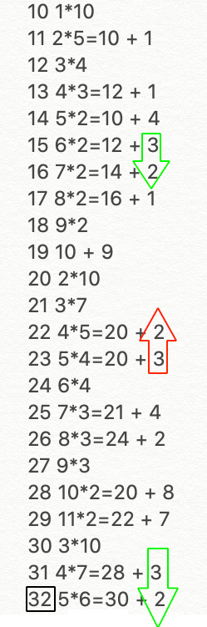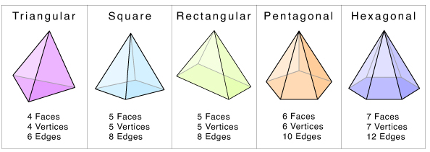Image provided by Paint X and Math Monk. Obviously there are more types of pyramids, as many as one can imagine to build.

Updates possible due to unproven math concepts being used.

[Edit](https://wordpress.com/post/gritplan.wordpress.com/973)

["Connected math art or pyramid teeth idea"](https://wordpress.com/post/gritplan.wordpress.com/973)

## [BENEFITS OF DARKNESS](https://gritplan.wordpress.com/2023/02/02/all-rolling-to-create-something-from-nothing-halts-under-my-say/)

Posted on [February 2, 2023](https://gritplan.wordpress.com/2023/02/02/all-rolling-to-create-something-from-nothing-halts-under-my-say/)

Light gets to take a break or operate at minimal sources meaning more sources for you to use for anything. Daytime takes a lot of energy to operate as nature is externally working and exchanging most during this time. Darkness allows new visions to be had easily as this is the same background that rem sleep provides but that doesn’t mean a single light every now and then disrupts the darkness as the dark sometimes can overpower minimal light.

Dark sources are mainly air, gases, oils, wind depending on locations, solar if you stored, lunar, water depending on flow paths and cycles and all sources not mainstream yet. These are free to max use during darkness as use of any sources is lowest when light is absent. Darkness provides more peace, introspection, harmony, solitude and stillness as it is less noisy generally and less cluttered with life.

[Edit](https://wordpress.com/post/gritplan.wordpress.com/967)

["Benefits of darkness"](https://wordpress.com/post/gritplan.wordpress.com/967)

## [DIFFERENCES ARE NECESSARY DUE TO CURRENT FAST PACED WORLD WE LIVE IN TODAY.](https://gritplan.wordpress.com/2023/01/26/accepting-differences-in-necessary-due-to-current-fast-paced-world-we-live-in-today/)

Posted on [January 26, 2023](https://gritplan.wordpress.com/2023/01/26/accepting-differences-in-necessary-due-to-current-fast-paced-world-we-live-in-today/)

With the amount of small business displayed widespread publicly today compared to the last century means we have to overlook nuisances that pop up daily and not spend so much time dwelling on it if doesn’t impact you directly. Spending countless hours finding out everything about everybody add ups and takes away from your time. Learn to balance and focus on what impacts you. Helping others can be cumulatively achieved also or in batches not necessarily one by one.

[Edit](https://wordpress.com/post/gritplan.wordpress.com/955)

["Differences are necessary due to current fast paced world we live in today."](https://wordpress.com/post/gritplan.wordpress.com/955)

## [WHAT GOES AROUND COMES AROUND](https://gritplan.wordpress.com/2023/01/25/what-goes-around-comes-around/)

Posted on [January 25, 2023](https://gritplan.wordpress.com/2023/01/25/what-goes-around-comes-around/)

When you purposefully initiate energy to make something negative or harm someone that did not deserve it, the universe has trouble processing it. That does not imply the action does not go through at different points, what you see is the results of it passing at different stages. The action backfires at known and unknown times that either build up, come out gradually or appear if it was not meant to be.

Think you kill an insect ungracefully, that action was not framed into the world as we, in hindsight, view how some big dinosaurs interacted with small insects during tree interactions. Obviously the insects would avoid the dinosaurs path if they wanted to survive and the dinosaurs, if they were created with any sense, avoided destroying smaller creatures that were beneficial, rather than harmful to the ecosystem during that period. Life was made of very little and the effects of karma were swift as evidence of major extinctions. Thats not to say the good dinosaurs were not carried over via salvageable recyclable living matter.

[Edit](https://wordpress.com/post/gritplan.wordpress.com/952)

["What goes around comes around"](https://wordpress.com/post/gritplan.wordpress.com/952)

## [TAKING A BREAK FOR A WHILE. GOOD AND BAD.](https://gritplan.wordpress.com/2023/01/19/taking-a-break-for-a-while-good-and-bad/)

Posted on [January 19, 2023](https://gritplan.wordpress.com/2023/01/19/taking-a-break-for-a-while-good-and-bad/)

This is incomplete obviously.

Good

People will gain understanding of the grit world possibly from others bringing new creativity to life that grit people are always able to achieve. Now it can come from grit people and non grit people both, if that is such a thing.

Bad

Not going to open that door.

[Edit](https://wordpress.com/post/gritplan.wordpress.com/942)

["Taking a break for a while. Good and bad."](https://wordpress.com/post/gritplan.wordpress.com/942)

## [PRESERVE WHATS CREATED OR POSSIBLE PROBLEMS LATER](https://gritplan.wordpress.com/2023/01/19/preserve-whats-created-or-possible-problem-later/)

Posted on [January 19, 2023](https://gritplan.wordpress.com/2023/01/19/preserve-whats-created-or-possible-problem-later/)

You need to preserve what’s created no matter how little, insignificant or not needed it is at the moment. Using a wrecking ball, or purposely destroying any creation is a sin people only find through hindsight or when it’s too late. Even if it’s a temporary destruction and you believe you can recreate it, nobody knows what that creation is connected to that could wreck itself somehow in the meantime. For example say you wreck somebody’s fingernail on purposes because they did something you believed was wrong. You can’t prove what you believe all the time and that fingernail or toenail could be connected to nature somehow by identifying what color is in trend through the nail. Destroying could wreck that entire trend communication which could in turn destroy something greater like what color a hot air balloon flies on certain days or what color a team chooses to represent.

[Edit](https://wordpress.com/post/gritplan.wordpress.com/939)

["Preserve whats created or possible problems later"](https://wordpress.com/post/gritplan.wordpress.com/939)

## [PEOPLE SHOULD BE ON THE SAME PAGE POST CORONA, NOT ALL OVER THE PLACE ON MANY ISSUES.](https://gritplan.wordpress.com/2023/01/19/theres-to-much-greed-during-post-corona-which-is-a-bad-direction-that-decade-started-in-a-lot-uncertain-can-happen-during-this-time-period-as-people-should-be-on-the-same-page-post-corona-not-greedy/)

Posted on [January 19, 2023](https://gritplan.wordpress.com/2023/01/19/theres-to-much-greed-during-post-corona-which-is-a-bad-direction-that-decade-started-in-a-lot-uncertain-can-happen-during-this-time-period-as-people-should-be-on-the-same-page-post-corona-not-greedy/)

Greed is defined by wanting more than you need, sometimes at the cost of someone or something else. After seeing a generation get wiped out, people should be sympathetic and less greedy, but its the other way, people are splurging, turning they’re back on one another and killing wildlife unmethodically. All this adds to a bad decade start as I cannot figure out what main item is driving this decade. 80s was cocaine, 90s was heroin, 2000’s was meth and 2010’s was a mix or just weed I believe. 70s was muscle cars and powerful automobiles with no limits in general but Im not sure if there was a a preferred substance involved. 60s was acid. But I could be wrong about these drug references, its unknown items being preferred is bad post corona as we should have general item that we all believe is a problem or a major hit that we idolize during this decade. No one seems to be able to get people on the same page about anything during 2020’s according to my obversavtions.

[Edit](https://wordpress.com/post/gritplan.wordpress.com/936)

["people should be on the same page post corona, not all over the place on many issues. "](https://wordpress.com/post/gritplan.wordpress.com/936)

## [MICROWAVES AND HEALING](https://gritplan.wordpress.com/2023/01/16/microwaves-and-healing/)

Posted on [January 16, 2023](https://gritplan.wordpress.com/2023/01/16/microwaves-and-healing/)

I could be wrong but I believe microwaves are harmful to anybody in any type of recovery. The taste of the food should send off alarms to anyone consuming. Think about it. For millenniums, society has been used to heating foods in a grill like method. The fire heats the food and any processes that need to occur can happen in the freedom of space. Microwaves are enclosed, terribly designed due to being micro waves possibly being trapped in a box to heat foodbe.

Micro waves, if they are contained in microwaves, like any type of wave should not be trapped in a box and then made to work. They should roam free and be part of nature. If microwaves do not contain micro waves, then they were misnamed and should be changed to another descriptor. Please use caution when heating food in this rushed 20th century creation. Eating foods without microwaves for two years have allowed parts of my body to heal that I never thought was possible, but once again I could be wrong.

[Edit](https://wordpress.com/post/gritplan.wordpress.com/924)

["Microwaves and healing"](https://wordpress.com/post/gritplan.wordpress.com/924)

## [HOW TO MAKE A PLAN](https://gritplan.wordpress.com/2022/11/18/how-to-make-a-plan/)

Posted on [November 18, 2022](https://gritplan.wordpress.com/2022/11/18/how-to-make-a-plan/)

<https://gritplan.wordpress.com/how-to-make-a-plan/>

[Edit](https://wordpress.com/post/gritplan.wordpress.com/874)

["How to make a plan"](https://wordpress.com/post/gritplan.wordpress.com/874)

## [WHEN YOU SHOULD ROLL, WHEN YOU SHOULD GO UP AND DOWN OR SOMETHING UNKNOWN.](https://gritplan.wordpress.com/2022/10/19/when-you-should-roll-when-you-should-go-up-and-down-or-something-unknown/)

Posted on [October 19, 2022](https://gritplan.wordpress.com/2022/10/19/when-you-should-roll-when-you-should-go-up-and-down-or-something-unknown/)

Rolling is connected to most objects we already possess, some compose our anatomy, many we consume daily . One can imagine these objects rolling and than can create a relation with two or more. This sets a dynamic relationship allowing objects into gaining and allocating resources from each other. Thus something essential is created in the background that rooted in nothing.

As far as up and down and something unknown they may come up in the future that both support and or surpass rolling.

[Edit](https://wordpress.com/post/gritplan.wordpress.com/858)

["When you should roll, when you should go up and down or something unknown."](https://wordpress.com/post/gritplan.wordpress.com/858)

## [PRIVATE: WHY YOU SHOULD NOT GET THE COVID VACCINE](https://gritplan.wordpress.com/2022/02/16/why-you-should-not-get-the-covid-vaccine/)

Posted on [February 16, 2022](https://gritplan.wordpress.com/2022/02/16/why-you-should-not-get-the-covid-vaccine/)



When you get a vaccine you are forcing your body to consume a medicine even when you are not infected. Undigested medicine has unknown effects on the human body that may not come to awareness until your body is recycled through ash or burial. Possibilities may arise as to your compatibility with non vaccinated individuals. We do not see the underlying processes/procedures that covid takes upon to infect an individual. Covid may infect more during introduction, middle to end or may not follow such a trend.  
Getting three shots of the vaccine and a booster is your choice. Remember nothing can take the shot out of your body but your own body processes. If you are concerned, stay tuned to those above and below you, to the left and right as covid travels rapidly vertically and horizontally through airspace.  
How covid starts and develops is known mainly to vaccine creators and the like.

[Edit](https://wordpress.com/post/gritplan.wordpress.com/827)

["Private: Why you should not get the covid vaccine"](https://wordpress.com/post/gritplan.wordpress.com/827)

## [PLANS OF CONCERN. FOLLOW PLANS, IF YOU BELIEVE IN IT.](https://gritplan.wordpress.com/2022/02/11/plans-of-concern-follow-plans-if-you-believe-in-it/)

Posted on [February 11, 2022](https://gritplan.wordpress.com/2022/02/11/plans-of-concern-follow-plans-if-you-believe-in-it/)

Clean any area you co exist with another creature, such as a dog. This could lead to problems in the future. Vacuum regularly, and understand things like carpets were made for people who own cars and have pets.

Be mindful of microwaves as you would not put food in a microwave for hours as you would on a stove, or oven. Microwaves are quick and not designed for everyone to use without studying it. To cook food that quickly, shortcuts must be happening in the food, or the environment. These will show up later, possibly when more people start traveling to the moon and beyond.

Cleaning the sea. The sea is home to millions. I need support in mass cleansing of sea so the tides are bit calmer.

[Edit](https://wordpress.com/post/gritplan.wordpress.com/824)

["Plans of concern. Follow plans, If you believe in it."](https://wordpress.com/post/gritplan.wordpress.com/824)

## [ALPHABET UPDATE](https://gritplan.wordpress.com/2022/02/01/alphabet-update/)

Posted on [February 1, 2022](https://gritplan.wordpress.com/2022/02/01/alphabet-update/)

A – Prestige

B- in, Bat, Blind, Bit

C- See, Magnet to everything consumable

D – Unused, Hard to use

E – Enter, exit, ethernet

F- Find, Fish, Food, First

G – God,

H – Home, Hiss, Horse

I- I

J – Joke, Jesus

K – King, ok

L – Final me, Like, Love, Lust, Lord, Left

M – Me, Moon

N – Needs

O – Pussy, Order

P – Pee, Phone

Q – Question

R – Rules, rights, roles, rides, rest

S – Curves, Our dents,

T – Turn, Truth, trust, Third, Thirst

U- Under

V – Victory

X- Crossroads

Y – Why

Z – Untouched

Please comment missed words, definitions

[Edit](https://wordpress.com/post/gritplan.wordpress.com/813)

["Alphabet update"](https://wordpress.com/post/gritplan.wordpress.com/813)

## [PRIVATE: TRUST LESS DURING COVID TIMES](https://gritplan.wordpress.com/2022/02/01/trust-less-during-covid-times/)

Posted on [February 1, 2022](https://gritplan.wordpress.com/2022/02/01/trust-less-during-covid-times/)

Dislodging and with the stars

A cB in?C old ?, road ?,B – lack, last? Lock?H – Lid?IKl  
 n O zoneLive RFood T   
Shif Tea

[Edit](https://wordpress.com/post/gritplan.wordpress.com/807)

["Private: Trust less during covid times"](https://wordpress.com/post/gritplan.wordpress.com/807)

## [HARVESTING NEW GRAPPLING CAUSED BY DRUG DYSFUNCTION](https://gritplan.wordpress.com/2022/01/24/harvesting-new-grappling-caused-by-drug-dysfunction/)

Posted on [January 24, 2022](https://gritplan.wordpress.com/2022/01/24/harvesting-new-grappling-caused-by-drug-dysfunction/)

Grappling are excess (runoffs) calculations from alcohol centric viewpoint for the environment. Linguistics can be defined as the progress and prosper of the human language. Grapes are produced in the same environment as other crops but our minor transferences (**trans references**) or (disputes on the definition of tr and trans). Transferences can be defined as transport or transfer references. So what new grappling brings is the fact that grapes can block . Grape p linguistics, can be defined as people, places, or things related to the progress and proper of the grape transference currently through alcohol religion. Astrology can be defined as the studies the symbol tr in the alphabet is deciphered in the words it contains. 8 words contain tr as a potentitonal symbol with 2 backups to the novice. Currently the . Trust, truth, travel, train, truck, tree ,track, trap with third and thirst as backups.

[Edit](https://wordpress.com/post/gritplan.wordpress.com/803)

["Harvesting new GRAPPLING caused by drug dysfunction"](https://wordpress.com/post/gritplan.wordpress.com/803)

## [PRIVATE: THE FARMER AND THE SHOTGUN PARABLE](https://gritplan.wordpress.com/2021/12/08/the-farmer-and-the-shotgun-parable/)

Posted on [December 8, 2021](https://gritplan.wordpress.com/2021/12/08/the-farmer-and-the-shotgun-parable/)

The disruption a firearm that goes off outdoors undesignated can cause to a farm, personal and external (to animals). You can see a fox or a squirrel peacefully eloping in the midst while a farmer with a shotgun unknowningly brings out heavy weaponry that can disrupt harmony (symetricaluation) occurring deep internally.

Each bullet you fire in this lifetime can be calculated and used naturally, either negatively or positively (very rare). Tread carefully when dealing with firearms; you do not want to disrupt bodies natural earth recycle processes that could have affects on your revival.

[Edit](https://wordpress.com/post/gritplan.wordpress.com/781)

["Private: The farmer and the shotgun parable"](https://wordpress.com/post/gritplan.wordpress.com/781)

## [PRIVATE: BIRD 10](https://gritplan.wordpress.com/2021/12/08/bird-measuring-10-units/)

Posted on [December 8, 2021](https://gritplan.wordpress.com/2021/12/08/bird-measuring-10-units/)

Bird 10Close up

There’s a natural power(force) behind everything.

Snake O, Bird O

A min video of the bird 10 shot

A way to capture a shot and name it with a quick term to help clear and further research into intranatural energy.

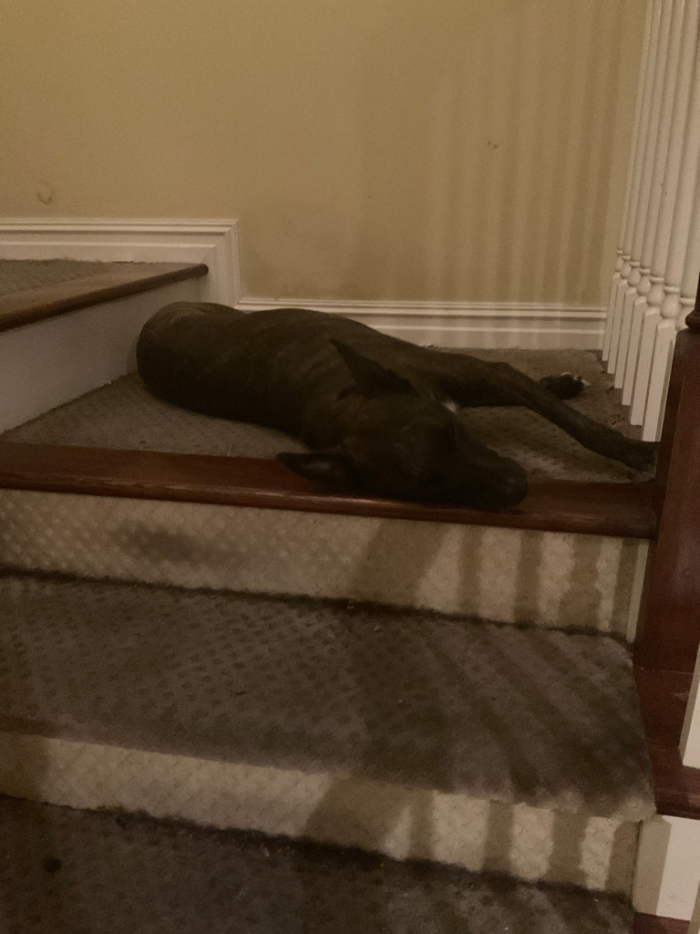Bonnie O

Bonnie Ha

Bonnie Eye

[Edit](https://wordpress.com/post/gritplan.wordpress.com/772)

["Private: Bird 10"](https://wordpress.com/post/gritplan.wordpress.com/772)

## [ALCOHOL RULES ACCORDING TO A BULLSHITTER](https://gritplan.wordpress.com/2021/09/13/alcohol-rules-according-to-a-bullshitter/)

Posted on [September 13, 2021](https://gritplan.wordpress.com/2021/09/13/alcohol-rules-according-to-a-bullshitter/)

Alcohol is a powerful substance that has ties to many places throughout our galaxy. Therefore it should be treated with respect.

We have a equator on earth that goes in a horizontal direction. Then when looking at a map of earth we also have time zones that go in vertical direction multiple times from west to east (or east to west). Drinking anything fermented that was produced in your time zone is asking for trouble(headaches and such). This is(according to me) because it doesn’t account for jet lag.

For example alcohol is not favorable among those obsess with the moon who are die hard fans (but I could be wrong).

To be continued…

[Edit](https://wordpress.com/post/gritplan.wordpress.com/729)

["Alcohol rules according to a bullshitter"](https://wordpress.com/post/gritplan.wordpress.com/729)

## [PLEASE BE MINDFUL OF FANS AND RELATED OBJECTS NEAR COCKROACHES.](https://gritplan.wordpress.com/2021/09/09/please-be-mindful-of-fans-and-related-objects-near-cockroaches/)

Posted on [September 9, 2021](https://gritplan.wordpress.com/2021/09/09/please-be-mindful-of-fans-and-related-objects-near-cockroaches/)

Cockroaches are important members in our ecosystem. Please value the efforts they put on a daily basis to locomotate. Do this by checking if any cockroaches are actively moving in the location you are in prior to turning on bathroom fans or any such related objects. You will reap the benefits of following this I am sure. It is not confirmed that bathroom fans have a negative impact on cockroaches.

[Edit](https://wordpress.com/post/gritplan.wordpress.com/722)

["Please be mindful of fans and related objects near cockroaches."](https://wordpress.com/post/gritplan.wordpress.com/722)

## [PRIVATE: PAPER CLEAR](https://gritplan.wordpress.com/2021/07/19/paper-clear/)

Posted on [July 19, 2021](https://gritplan.wordpress.com/2021/07/19/paper-clear/)

21

State blocks. Word blocks next. 5 letters and above only for now.

Vermont – Version Moon T – Jesus Block

Could mean anything. Start with V er M order n t. Version Money tree. V er Monday t. So don’t get stuck on one block.

Louisiana – Final Me orders u i curve (block) i ana, – not finished. The S could mean something else as I don’t u derstand S fully.

Michigan – Michelin I gain.

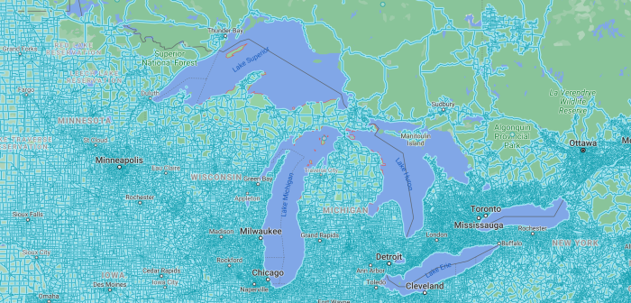

Kentucky -K enter any where tuck y. K enter any t u c King y. Tuc could be truth you see or truth you inverse radiate.

California – magnet a l I f ornament I a. Call I fornia – Jesus Block.

Arkansas –

Idaho –

[Edit](https://wordpress.com/post/gritplan.wordpress.com/660)

["Private: Paper clear"](https://wordpress.com/post/gritplan.wordpress.com/660)

## [HOW TO CLEAR ERRORS](https://gritplan.wordpress.com/2021/07/08/how-to-clear-errors/)

Posted on [July 8, 2021](https://gritplan.wordpress.com/2021/07/08/how-to-clear-errors/)

1. Walk your dog

a, In a consistent manner for better results (not confirmed)

b. Make sure the dog and you are hydrated (with ice preferably)

2. Smoke weed (in a legal state)

3. Get startled

a. Works better in a random setting

4. Take a shot

a. Any shot that you make works (ie. a basketball shot, a dartboard, the trashcan)

Continued on [https://numlum.blogspot.com/](https://numlum.blogspot.com/p/ways-to-clear-errors.html)

[Edit](https://wordpress.com/post/gritplan.wordpress.com/647)

["How to clear errors"](https://wordpress.com/post/gritplan.wordpress.com/647)

## [RIMETEXT: RISE AGAINST – SURVIVORS GUILT](https://gritplan.wordpress.com/2021/07/05/rimetext-rise-against-survivors-guilt/)

Posted on [July 5, 2021](https://gritplan.wordpress.com/2021/07/05/rimetext-rise-against-survivors-guilt/)

<https://www.instagram.com/peoplecollab/?hl=en>

[Edit](https://wordpress.com/post/gritplan.wordpress.com/645)

["Rimetext: Rise Against – Survivors Guilt"](https://wordpress.com/post/gritplan.wordpress.com/645)

## [PRIVATE: LIFE IS SHORT [SO THERE IS A NEED] FOR MULTIPLE (IDEALLY A SINGLE) ALPHABET DICTIONARY(S) THAT TRANSLATES DIRECTLY TO MEANINGS FOUND IN STANDARD DICTIONARIES 100% OF THE TIME.](https://gritplan.wordpress.com/2021/06/28/life-is-short-so-there-is-a-need-for-multiple-ideally-a-single-alphabet-dictionarys-that-translates-directly-to-meanings-found-in-standard-dictionaries-100-of-the-time/)

Posted on [June 28, 2021](https://gritplan.wordpress.com/2021/06/28/life-is-short-so-there-is-a-need-for-multiple-ideally-a-single-alphabet-dictionarys-that-translates-directly-to-meanings-found-in-standard-dictionaries-100-of-the-time/)

Alphabet dictionary 1 – Unknown title, in progress,

contents: A. Proofs, B. Single/Mutliple word translations, How to read word with translations and match meanings to other dictionaries.

Alphabet dictionary 2 – 2015 standard, in progress

[Edit](https://wordpress.com/post/gritplan.wordpress.com/637)

["Private: Life is short [so there is a need] for multiple (ideally a single) alphabet dictionary(s) that translates directly to meanings found in standard dictionaries 100% of the time."](https://wordpress.com/post/gritplan.wordpress.com/637)

## [PRIVATE: DANGERS OF CLEANING](https://gritplan.wordpress.com/2021/06/17/dangers-of-cleaning/)

Posted on [June 17, 2021](https://gritplan.wordpress.com/2021/06/17/dangers-of-cleaning/)

Full images at @peoplecollab image blocker

[Edit](https://wordpress.com/post/gritplan.wordpress.com/633)

["Private: Dangers of cleaning"](https://wordpress.com/post/gritplan.wordpress.com/633)

## [DEBATE BLOCKER AND REVERSE BLAST BLOCKER](https://gritplan.wordpress.com/2021/06/11/609/)

Posted on [June 11, 2021](https://gritplan.wordpress.com/2021/06/11/609/)

Persistent Image QAnon(?) Debate [Blocker](http://cfoode.wordpress.com/) sample

[View](http://cfoode.wordpress.com/)

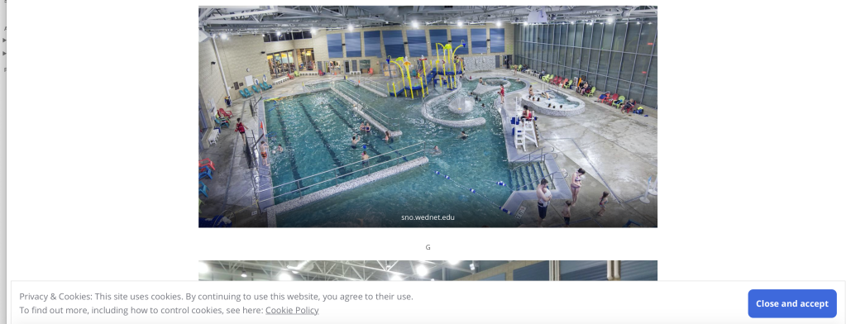

Coke can coke reverse blast with optional positive lid spark via needle. Can connect to a remote ir connected to a portable radio with insulation. Then you could ? Only use if your getting killed. Its works temporarily and is why a debate blocker is needed asap. Only create/use if absolutely necessary with proper loadouts so you don’t have to read into burnt residue left on the socket. Be careful as there could be bugs(entities) on the other side.

Search ionizing radiation devices/appliances which may be hindering debate blocks(?).

[Edit](https://wordpress.com/post/gritplan.wordpress.com/609)

["Debate blocker and reverse blast blocker"](https://wordpress.com/post/gritplan.wordpress.com/609)

## [PRIVATE: UPDATED ALPHABET MEANINGS (AROUND 75% COLLABORATION[GIVE OR TAKE]). NEED PROOF.](https://gritplan.wordpress.com/2021/06/08/dear-lord-today-i-lift-up-my-family/)

Posted on [June 8, 2021](https://gritplan.wordpress.com/2021/06/08/dear-lord-today-i-lift-up-my-family/)

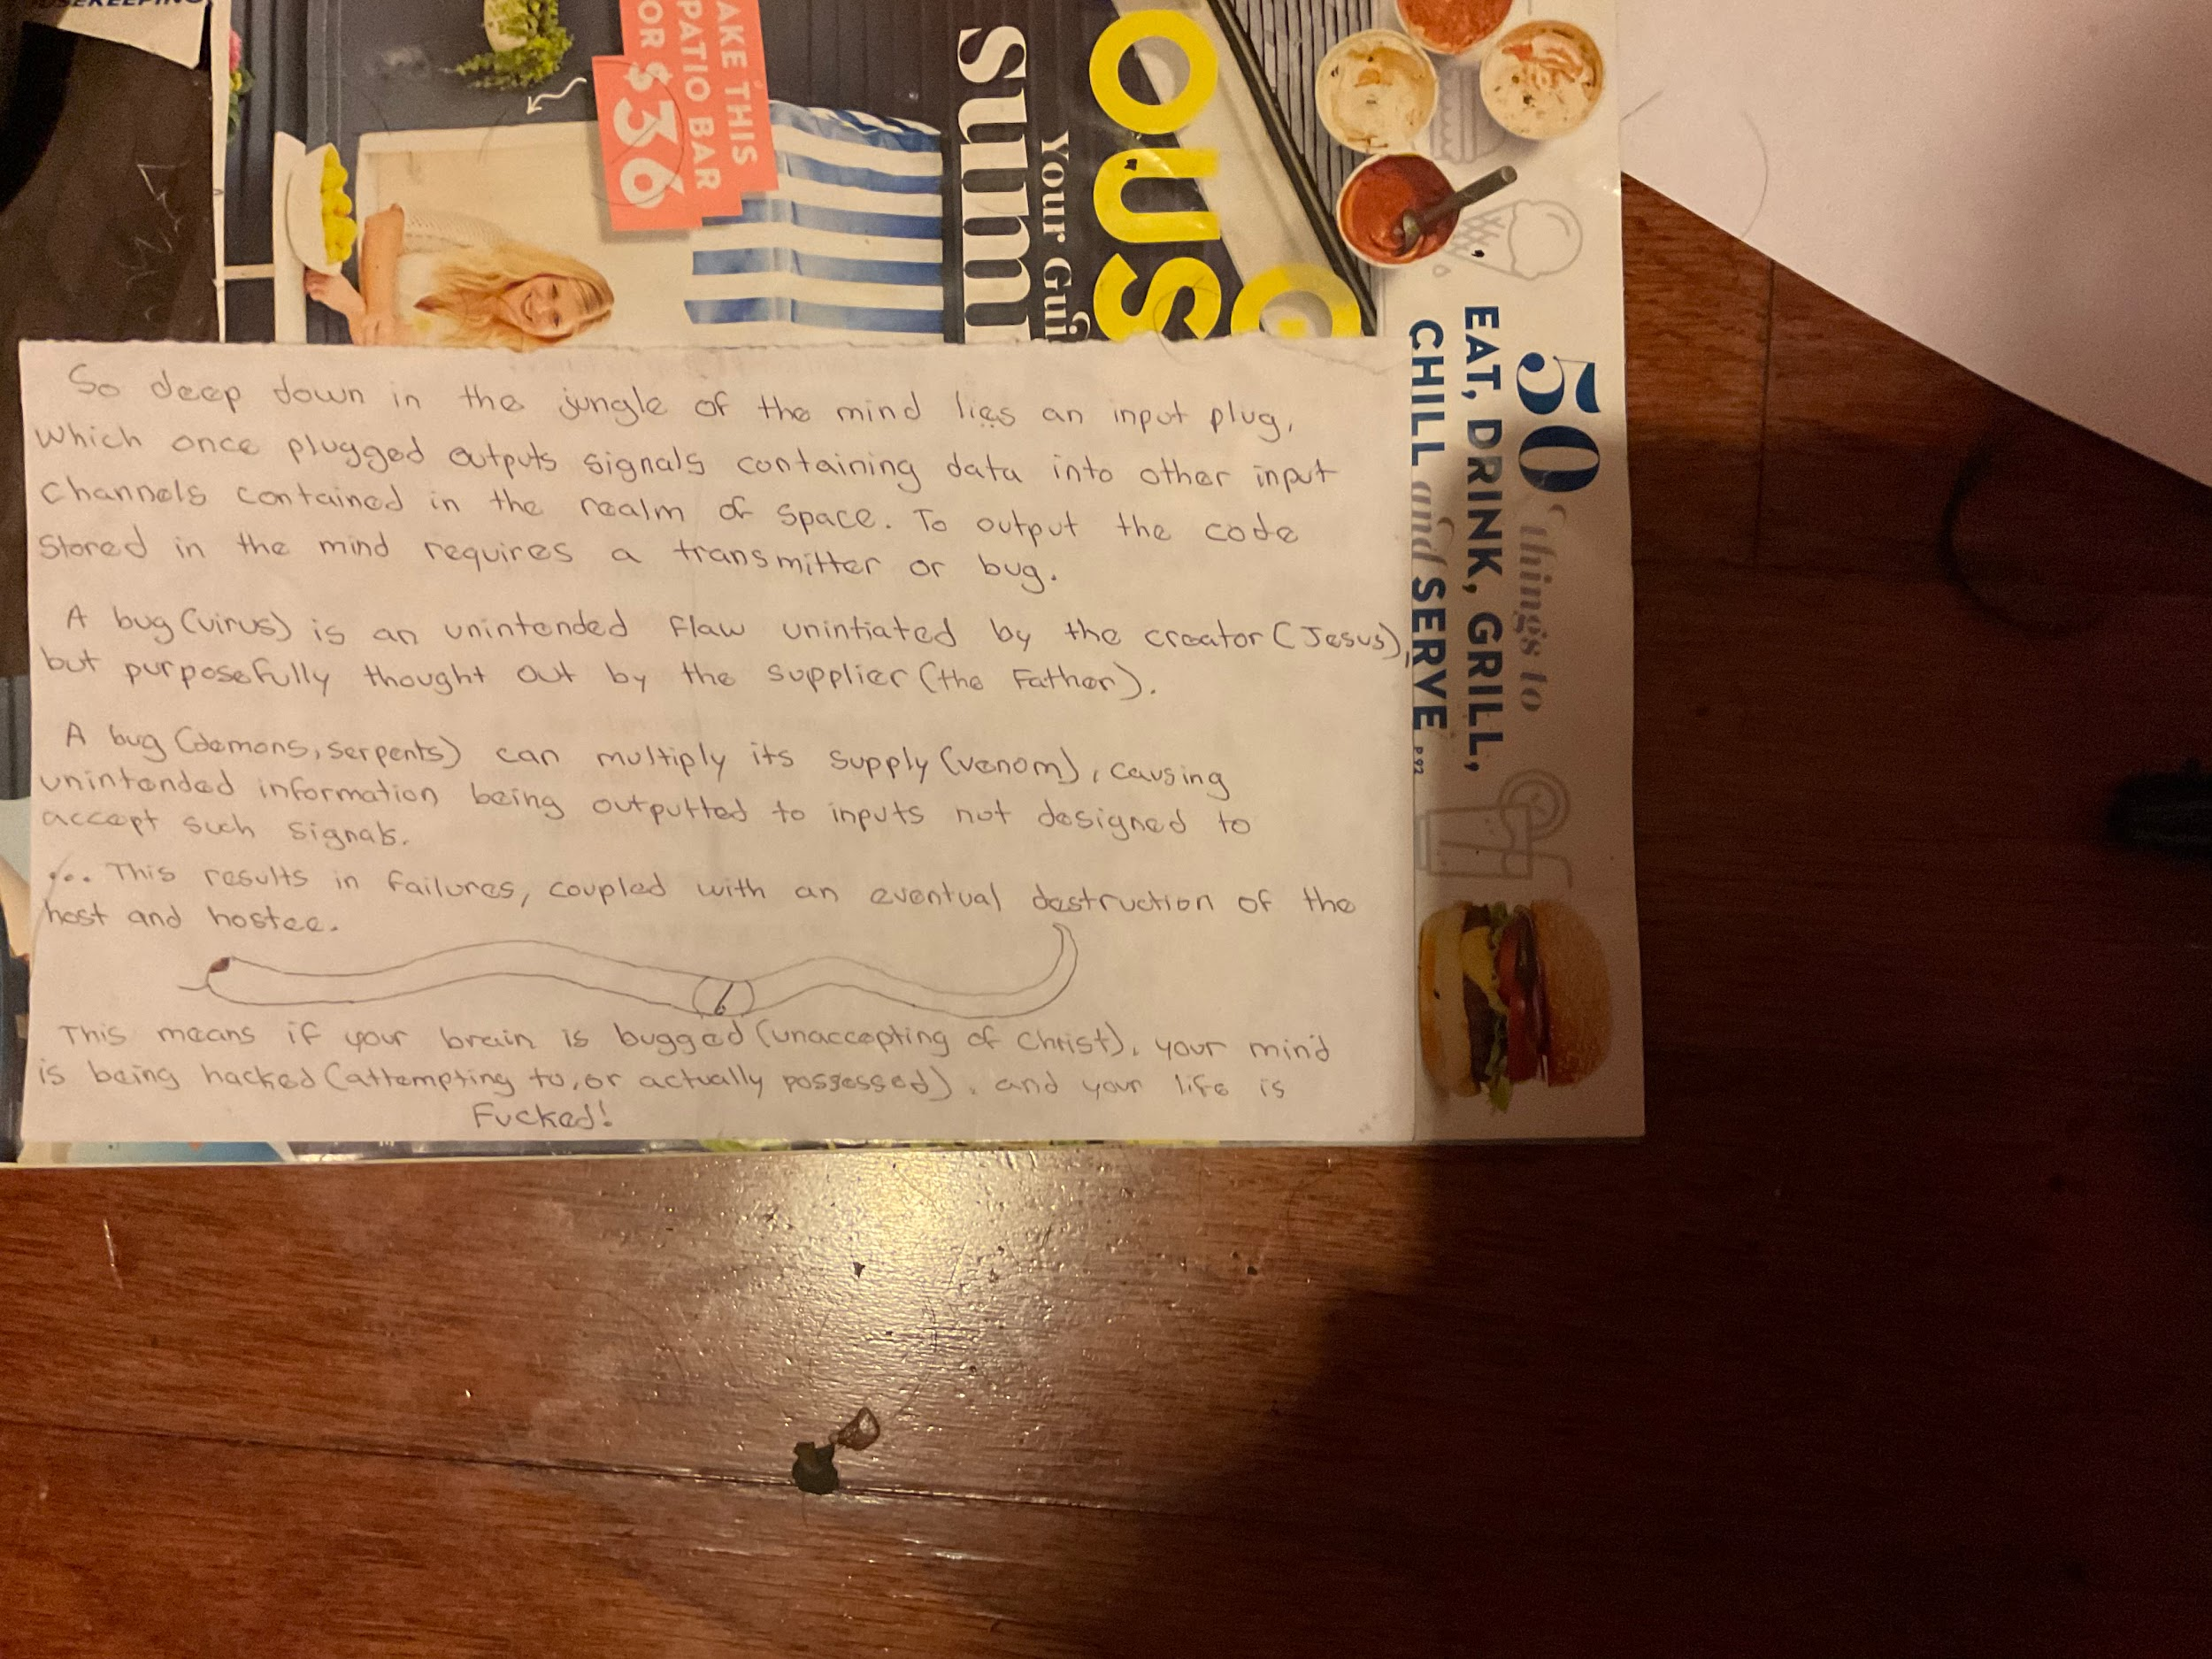

Something confusing I wrote years ago when I was breaking down life.

Car analogy: Think about multiple occupants. A car can seat 4-5 spirits or more. A bus can fit 30 or more. The bigger (fatter) you get the more sounds you can contain. The more cramped(souls) in you the more you weighted down. The slower you get. You need to empty(cleanse) your car(body) from passengers(souls). Open doors and release them. Then shut the door and lock it.

Your brain, your eyes are the windshield. Brain houses the cabin of the vehicle, which houses the occupants. Make sure what(or who) you let cross that blood-brain barrier is of clean souls/spirits. Make sure you are the driver.

Updated alphabet meanings. My version, not too much in collaboration. These translations should allow you to look at any word, and by matching each letter below to your word should allow you to define it without a dictionary (unproven, yet not disproven).

Please comment if you have any suggestion to what the letters mean based on a universal understanding among all entities (includes animals).

A –

B –

C – See(sight) or Magnet ?

D –

E – Enter, exit

F –

H – Home

I – You or i

J – Jesus

K – Ok or king, depending on times ?

L – Where you(I) is complete

M – Same direction

N – No or any direction ?

O – Order

P – Pee

Q –

R – Rime

S –

T – Fight, truth, sword, depending on times?

U – You ?

V –

W –

X –

Y – Why (except for 0.1% could be something else)

Z –

[Edit](https://wordpress.com/post/gritplan.wordpress.com/589)

["Private: Updated Alphabet meanings (around 75% collaboration[give or take]). Need proof."](https://wordpress.com/post/gritplan.wordpress.com/589)

## [PRIVATE: INJECTED LAND MASS](https://gritplan.wordpress.com/2021/05/24/injected-land-mass/)

Posted on [May 24, 2021](https://gritplan.wordpress.com/2021/05/24/injected-land-mass/)Could be anything.Look at the top right.

[Edit](https://wordpress.com/post/gritplan.wordpress.com/575)

["Private: Injected land mass"](https://wordpress.com/post/gritplan.wordpress.com/575)

## [PRIVATE: JA PROOF?](https://gritplan.wordpress.com/2021/05/23/ja-proof/)

Posted on [May 23, 2021](https://gritplan.wordpress.com/2021/05/23/ja-proof/)

Alphabet A – J translation proof possibly?

[Edit](https://wordpress.com/post/gritplan.wordpress.com/568)

["Private: JA Proof?"](https://wordpress.com/post/gritplan.wordpress.com/568)

## [GLOCK RIGHT PLAN – DEFINE WORDS PROPERLY – NOT 100%R – MORE LIKE THOUGHTS](https://gritplan.wordpress.com/2021/05/02/glock-right-plan-define-words-properly/)

Posted on [May 2, 2021](https://gritplan.wordpress.com/2021/05/02/glock-right-plan-define-words-properly/)

Vita manual

Microwave – [Read more](https://wordpress.com/page/iceqt.wordpress.com/161).

Vitamins:

V I ta m ins

Vape I ta m ins

Use minerals to output your immune interactions with vitamins in clay logic system.

-Vitamin A – So building of this logic if you have mainly preformed A then try to shift to pro A if not blocked from fruits, vegetables and produce. If you have preformed A as part of a multi-vitamin regime it might be best to stick to preformed for brief periods. Pro A will give you more ins as you can control it but this logic could be wrong as preformed A is already calibrated to generate a certain deficit. It’s best to research further.

-Vitamin K – Can reproduce functions in the body in dosages. When used together with vitamin A could generate personal immune blocks.

Vitamin related:

Minerals:

Potassium – Self responsibility and accountability for others

Calcium – Related to potassium, Calculations and non-related non responses

Magnesium -Related by “ium” ending to calcium and potassium. Important in frame working, possibly with other minerals. Sometimes its best to not track.

Apatite – Apart, tight

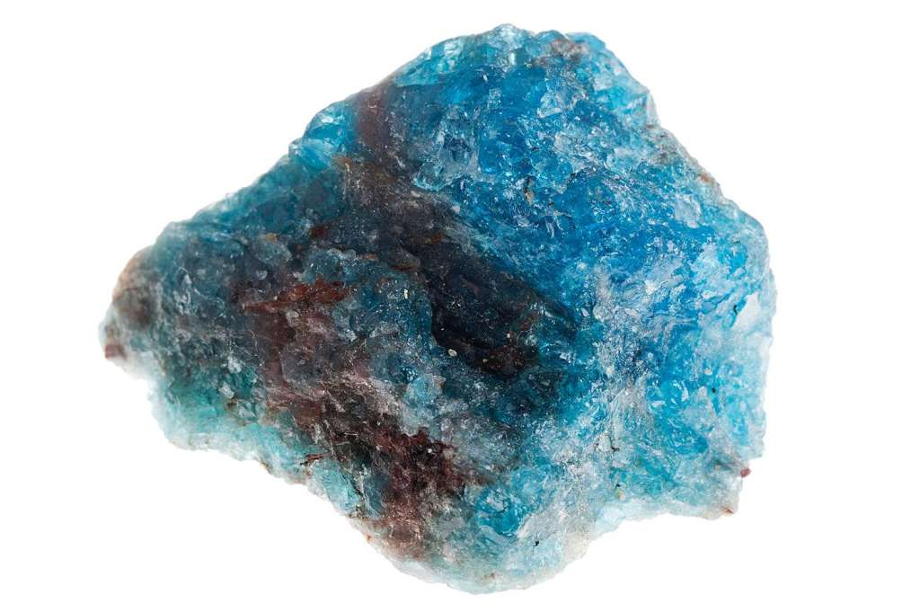

Cordierite – C Order i er i-t-e, or Cord i e right – Could be used in finalizing frameworks.

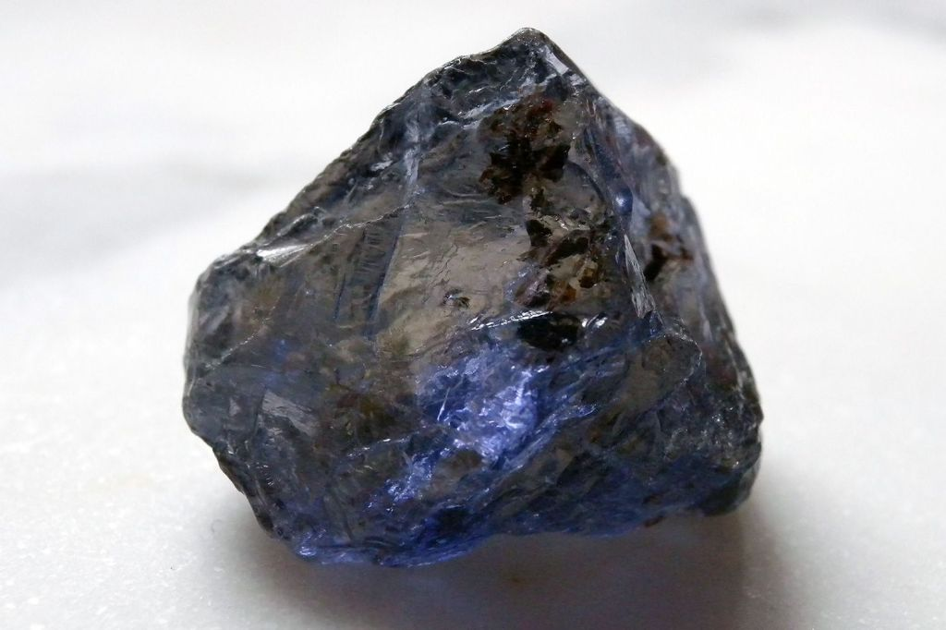

Arsenate – Simple decode, a and/or r sea and ate.

Cabalzarite – Possibaly will take years to decode/decide. Rare arsenate mineral.

Cadmium – Complicated will return when “ium” is studied further.

Cadmoindite – Is a rare cadmium indium sulfide mineral. Possibly relates to why cadmium is hard to decode.

Diamond – Complicated possibly safer to wait instead of decoding completely on your own. My block currently.

Edenite – Confusing spelling, hard to define currently. Could mean something completely different or eden nite or ?. Best guess, E den i-t-e.

Evenkite – Simple block, glock. Could be glocked further than even-kite to even k i-t-e. Could be metaphor blocked to mean balance your own hand work.

Unknown any further.

[Edit](https://wordpress.com/post/gritplan.wordpress.com/524)

["Glock right plan – Define words properly – Not 100%R – More like thoughts"](https://wordpress.com/post/gritplan.wordpress.com/524)

## [PROGRESS ON RIMECALL](https://gritplan.wordpress.com/2021/03/21/progress-on-rimecall/)

Posted on [March 21, 2021](https://gritplan.wordpress.com/2021/03/21/progress-on-rimecall/)

Still developing using Googles AppSheet, to create a database for the trees.

[Edit](https://wordpress.com/post/gritplan.wordpress.com/511)

["Progress on rimecall"](https://wordpress.com/post/gritplan.wordpress.com/511)

## [PLASTIC POLLUTION, A CAUSE FOR CONCERN.](https://gritplan.wordpress.com/2021/02/18/plastic-pollution-a-cause-for-concern/)

Posted on [February 18, 2021](https://gritplan.wordpress.com/2021/02/18/plastic-pollution-a-cause-for-concern/)

In 2008, our global plastic consumption worldwide has been estimated at 260 million tons, think about how many cars that is ending up in another galaxy of stars light years away. Now in 2015 it is 381 million tons. Eventually a problem will arise. Think about it. Our consumption is going up not down. Just look at polluted beaches worldwide.

Ocean wildlife are not good at recycling plastic. Please help dispose plastic properly!

[When The Mermaids Cry: The Great Plastic Tide](https://plastic-pollution.org/)

[plastic-pollution.org](https://plastic-pollution.org/)

[Edit](https://wordpress.com/post/gritplan.wordpress.com/487)

["Plastic pollution, a cause for concern."](https://wordpress.com/post/gritplan.wordpress.com/487)

## [MY ULTIMATE FINAL VERDICT FOR THE SITE](https://gritplan.wordpress.com/2021/02/18/my-ultimate-final-verdict-for-the-site/)

Posted on [February 18, 2021](https://gritplan.wordpress.com/2021/02/18/my-ultimate-final-verdict-for-the-site/)

To make an online church

There is a few up and running but I believe I can make [peoplecollab.com](http://www.peoplecollab.com/) an online church, and Gritplan as the blog. I would have to go back to school and do all the coding from the ground up but it can be done the way I imagine only it will take a few a years and a lot of luck. I have a lot to give when it comes to church, and because of covid people will be more inclined to attend a church online.

I sort of gave up on the emergency plans for the time being, since I do not see the homeless making much use of it.

My last idea was [rimecall](http://www.rimecall.com/)

If I **focus on reading trees and talking to birds to create a calling system for nature**

**So if I read trees in certain categories in a certain location in realtime (possibly from yearly maps- weather updates) I can talk to birds in that location by decoding my origina**l work.

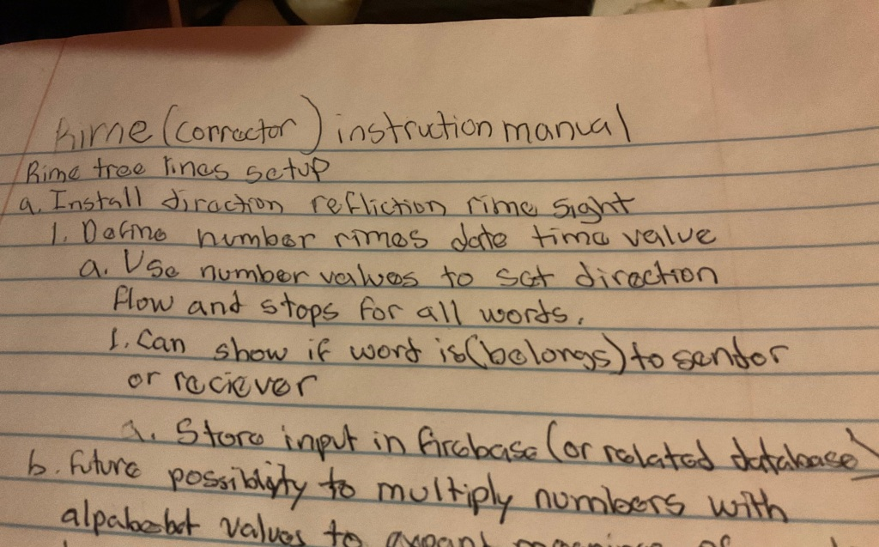

[Edit](https://wordpress.com/post/gritplan.wordpress.com/467)

["My ultimate final verdict for the site"](https://wordpress.com/post/gritplan.wordpress.com/467)

## [IMPORTANT, PLEASE READ!](https://gritplan.wordpress.com/2021/02/04/important-please-read/)

Posted on [February 4, 2021](https://gritplan.wordpress.com/2021/02/04/important-please-read/)

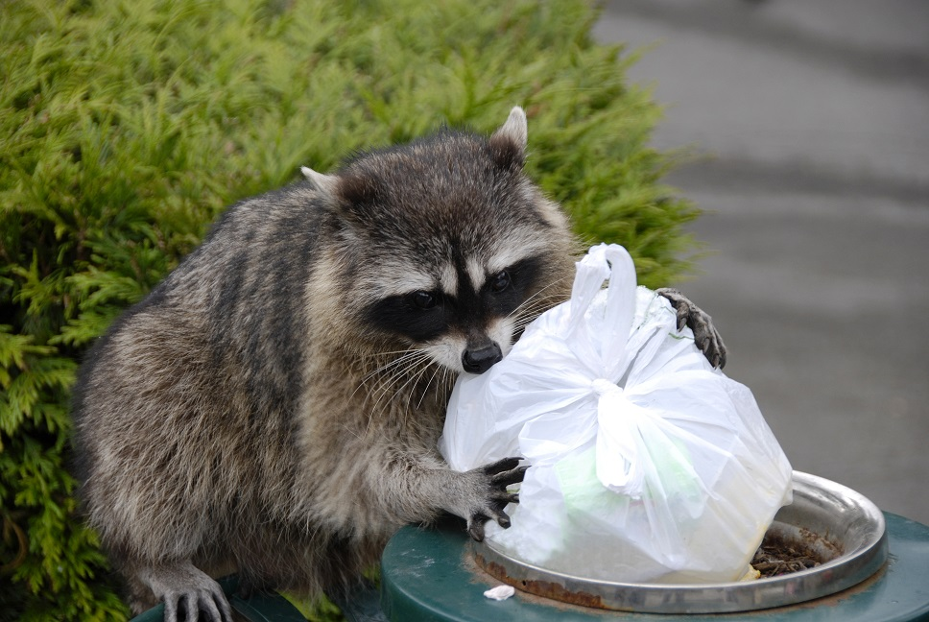

**Animals are looking through trash bags on the streets for food. We need a unified system/color to throw needles away that animals know to look for. Cont. below.**

Black

Blue

Both

Other

**VOTE**

View Results[Crowdsignal.com](https://crowdsignal.com/pricing/?ad=poll-front)

continued….OTHER THEN PLASTIC CONTAINERS, ONE BECAUSE OF ACCESS, TWO BECAUSE OF PLASTIC POLLUTION. NEED SUPPORT IN SPREADING THIS MESSAGE. So I recommenced black or blue because punches to the face look black or blue bruised. Since most animals faces make up most of their body compared to humans (us), and they see a lot more in life then we think, they value their face a lot. They would recognize black and blue as danger if it spreads amongst multiple species. If you have another recommendation please speak up because of concerns of pop-tart boxes colored blue/black which to some creatures eyes could be mistaken and because pop-tart is a common food that could be mistaken by some animal as food.

[2 Comments](https://gritplan.wordpress.com/2021/02/04/important-please-read/#comments)[Edit](https://wordpress.com/post/gritplan.wordpress.com/444)

["Important, Please Read!"](https://wordpress.com/post/gritplan.wordpress.com/444)

## [A WAY TO END COVID ACCORDING TO MY LOGIC – MAINTAIN SOCIAL DISTANSING](https://gritplan.wordpress.com/2020/11/19/a-way-to-end-covid-according-to-my-logic-maintain-social-distansing/)

Posted on [November 19, 2020](https://gritplan.wordpress.com/2020/11/19/a-way-to-end-covid-according-to-my-logic-maintain-social-distansing/)

Covid lasts for approximatly two weeks I believe. In that time frame the more people you are in contact with, the greater chance for it to spread. Thats why its so persasvive, my website will aid in giving people support by reducing person to person contact, all if I can create it soon enough.

I will update with more proof later

[Edit](https://wordpress.com/post/gritplan.wordpress.com/367)

["A way to end covid according to my logic – Maintain social distansing"](https://wordpress.com/post/gritplan.wordpress.com/367)

## [PRIVATE: AN UPDATE TO THE ALPHABET TRANSLATION I HAD COMPILED ABOUT A YEAR OR SO AGO(SCROLL TO MY FIRST POSTS). THIS TRANSLATION IS DONE THROUGH MY READINGS OF THE BIBLE AND MY LIFE EXPERIENCES.](https://gritplan.wordpress.com/2020/11/19/an-update-to-the-alphabet-translation-i-had-compiled-about-a-year-agoscroll-to-my-first-posts-this-translation-is-done-through-my-readings-of-the-bible-and-my-life-experiences/)

Posted on [November 19, 2020](https://gritplan.wordpress.com/2020/11/19/an-update-to-the-alphabet-translation-i-had-compiled-about-a-year-agoscroll-to-my-first-posts-this-translation-is-done-through-my-readings-of-the-bible-and-my-life-experiences/)

a – not to be touched, unknown for now

b- blind or something else, unknown beside blind- could change

c- magnet, remains the same from a year or so ago – very powerful. Its up to you follow the translation, but I worked hard with owls, birds, my dog and a lot of unknown beings.

d – dog or dee(like used as someones name) – could add another translation possibly later

e – enter, exit

f- unknown for now

g – god, could add change or subtract, (forgot to put before I walked Bonnie when I updated my system with birds and sun creatures/people – ignore the parantheisis if it doesnt make sense)

h – symbolizes a dwelling with a flage at the up right most point of h so aqa flag is always on the left side when you wtite h or it is depicted to others. Will update with a symbol(drawing) later.

i- is i, you basically

j- I want to say jes before it became Jesus but im not a hundred percent sure. I do know at the three point jes adds US like the country to become 5, the name king(unsure of this title) Jesus.

k- king or unsure, could change or remain and add another translation.

l- Is when you (i) becomes final, as this is what you want to be for eternity. Very powerful charachter. Not 100, about 99 percent sure about this translation.

Ill start m in another post, sorry for the delay to those who follow.

-very important post, could lead to us communicating to all beings without learing their full language.

-I am pentacostal, so i speak in tongues – I got this rare update at work recently – thank you Jesus.

[Edit](https://wordpress.com/post/gritplan.wordpress.com/352)

["Private: An update to the alphabet translation I had compiled about a year or so ago(scroll to my first posts). This translation is done through my readings of the bible and my life experiences."](https://wordpress.com/post/gritplan.wordpress.com/352)

## [SECOND IDEA](https://gritplan.wordpress.com/2020/10/07/second-idea/)

Posted on [October 7, 2020](https://gritplan.wordpress.com/2020/10/07/second-idea/)

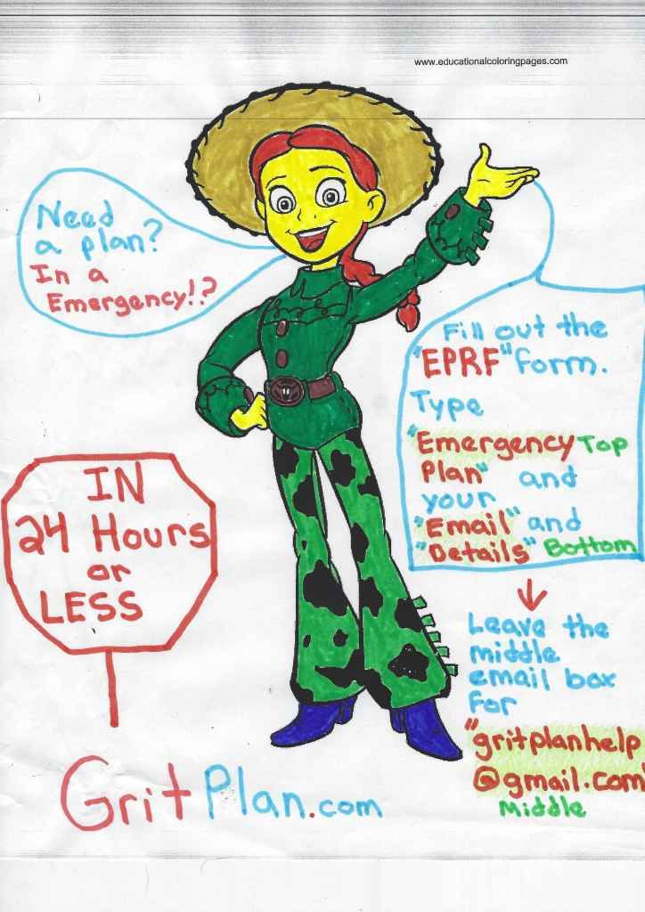

It will probably take 2 years, give or take to gurantee the 24 hours, but im working on it.

[Edit](https://wordpress.com/post/gritplan.wordpress.com/340)

["Second idea"](https://wordpress.com/post/gritplan.wordpress.com/340)

## [MY ULTIMATE GOAL FOR THE SITE. I HAVE 2 IDEAES. BUT THEY BOTH CAN HAPPEN I BELIEVE. HERES ONE.](https://gritplan.wordpress.com/2020/10/07/my-ultimate-goal-for-the-site-i-have-2-ideaes-but-they-both-can-happen-i-believe-heres-one/)

Posted on [October 7, 2020](https://gritplan.wordpress.com/2020/10/07/my-ultimate-goal-for-the-site-i-have-2-ideaes-but-they-both-can-happen-i-believe-heres-one/)

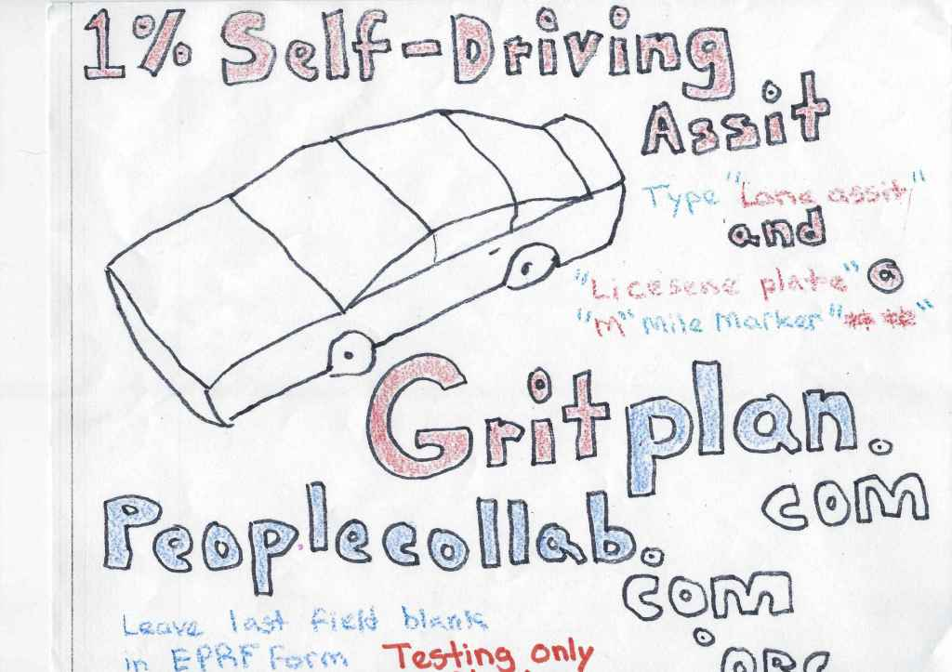

<https://gritplan-start.firebaseio.com/>

[Edit](https://wordpress.com/post/gritplan.wordpress.com/332)

["My ultimate goal for the site. I have 2 ideaes. But they both can happen I believe. Heres one."](https://wordpress.com/post/gritplan.wordpress.com/332)

## [WHEN YOU SHOOT DRUGS, INSULIN, OR ANYTHING, HOW IT RELATES TO THE EARTH AND HEAVEN AROUND YOU. ACCORDING TO ME.](https://gritplan.wordpress.com/2020/10/06/when-you-shoot-drugs-insulin-or-anything-how-it-relates-to-the-earth-and-heaven-around-you-according-to-me/)

Posted on [October 6, 2020](https://gritplan.wordpress.com/2020/10/06/when-you-shoot-drugs-insulin-or-anything-how-it-relates-to-the-earth-and-heaven-around-you-according-to-me/)

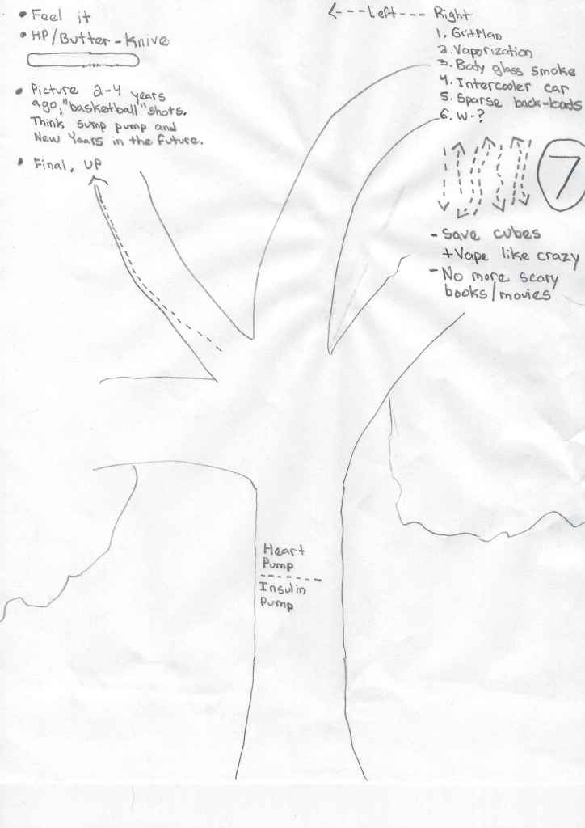

[Edit](https://wordpress.com/post/gritplan.wordpress.com/326)

["When you shoot drugs, insulin, or anything, how it relates to the earth and heaven around you. According to me."](https://wordpress.com/post/gritplan.wordpress.com/326)

## [CRISIS PLANS](https://gritplan.wordpress.com/2020/08/08/crisis-plans/)

Posted on [August 8, 2020](https://gritplan.wordpress.com/2020/08/08/crisis-plans/)

Death plans

Robbery plans

* Always give up money/possesions 100% of the time if a gun is involved.

Theft plans

Accidents plans

Natural disaster plans

[Edit](https://wordpress.com/post/gritplan.wordpress.com/304)

["Crisis Plans"](https://wordpress.com/post/gritplan.wordpress.com/304)

## [PRIVATE: DRUG PLANS](https://gritplan.wordpress.com/2020/08/08/drug-plans/)

Posted on [August 8, 2020](https://gritplan.wordpress.com/2020/08/08/drug-plans/)

Alcohol plans

Marijuana plans

* The middle drug, not a complete downer or upper.

Cocaine plans

Dextromethorphan plans

Heroin plans

Methamphetamine plans

[Edit](https://wordpress.com/post/gritplan.wordpress.com/300)

["Private: Drug plans"](https://wordpress.com/post/gritplan.wordpress.com/300)

Posted on [December 13, 2019](https://gritplan.wordpress.com/2019/12/13/227/)



The Bible that pushed my journey/ saved my life.

Tagged [respect bible](https://gritplan.wordpress.com/tag/respect-bible/)[Edit](https://wordpress.com/post/gritplan.wordpress.com/227)

## [LOVE, BEAUTY – MADE POSSIBLE THROUGH CHRISTIANITY](https://gritplan.wordpress.com/2019/12/13/love-beauty-made-possible-through-christianity/)

Posted on [December 13, 2019](https://gritplan.wordpress.com/2019/12/13/love-beauty-made-possible-through-christianity/)

[my.w.tt/dZjXMi1vn2](https://my.w.tt/dZjXMi1vn2)

Tagged [respect](https://gritplan.wordpress.com/tag/respect/)[Edit](https://wordpress.com/post/gritplan.wordpress.com/221)

["Love, Beauty – made possible through Christianity"](https://wordpress.com/post/gritplan.wordpress.com/221)

## [HI](https://gritplan.wordpress.com/2019/12/02/hi/)

Posted on [December 2, 2019](https://gritplan.wordpress.com/2019/12/02/hi/)

[my.w.tt/KoyLqjx351](https://my.w.tt/KoyLqjx351)

Send messages via blogs

Tagged [‘](https://gritplan.wordpress.com/tag/690726131/)[Edit](https://wordpress.com/post/gritplan.wordpress.com/219)

["Hi"](https://wordpress.com/post/gritplan.wordpress.com/219)

## [PROPER WAYS TO CLEAN AND THE IMPORTANCE OF IT.](https://gritplan.wordpress.com/2019/12/01/proper-ways-to-clean-and-the-importance-of-it/)

Posted on [December 1, 2019](https://gritplan.wordpress.com/2019/12/01/proper-ways-to-clean-and-the-importance-of-it/)

[Edit](https://wordpress.com/post/gritplan.wordpress.com/196)

["Proper ways to clean and the importance of it."](https://wordpress.com/post/gritplan.wordpress.com/196)

## [WELCOME](https://gritplan.wordpress.com/2019/11/07/welcome/)

Posted on [November 7, 2019](https://gritplan.wordpress.com/2019/11/07/welcome/)

Start asking for rules

[5 Comments](https://gritplan.wordpress.com/2019/11/07/welcome/#comments)[Edit](https://wordpress.com/post/gritplan.wordpress.com/160)

["Welcome"](https://wordpress.com/post/gritplan.wordpress.com/160)

## [WHY ADDICTION IS BAD!](https://gritplan.wordpress.com/2019/05/17/why-addiction-is-bad/)

Posted on [May 17, 2019](https://gritplan.wordpress.com/2019/05/17/why-addiction-is-bad/)

Addiction is the definition of insanity. Why would you purposefully spend money to make yourself feel better, when you spend most of your life trying to earn money in the first place. To break the chain of addiction you have to invest in yourself, which is hard thing to do. Once you start spending money or time on yourself, the amount of money you spend on yourself and the nature of addiction will go away on its own.

Addiction is the act of investing more time and money that you have on yourself to feel better. The reason being is that time is precious and goes away day to day, and money is effort and struggle on your part to make your future time less of a struggle. The less struggle you have in the future the easier that time will be spent. If you use drugs, food, movies, alcohol, racing anything not too healthy will make your future time better, but will cause you to waste your work( hard earned money that you made struggling by working) and then cause you to work more in the future to earn that money back.

You start in the beginning only hooked on the simple pleasure boosters in life such as extra movies or extra junk food. It satisfies the craving for a while but slowly it makes you a slave by making your brain dependent on that boost of happiness. After a while you crave a stronger rush, a more longer high a brain – numbing exctasy that pushes your brain to cold numbness of euphoria that’s not cold by temperature but cold because it’s so pleasurable. You want your eyes to roll back in your head while your brain becomes like a muscle or an engine (like the heart), pumping out pleasurable chemical processes in all directions making your entire body warm, not the temperature warm but the pure happiness that your entire body is in pleasure warm. The body has no work to do and is being rewarded for nothing.

Thats when your addiction is out of control.

Most people might not get to that point of despair, the dark hole. Where every penny you get is allocated to the next flight to the moon. If I spend $60 I can go to the moon, maybe stop by Jupiter, and hopefully get some airtime in Pluto, all in a week and half. The entire trip I will be wrapped up in warm exctascy. No pain, no hurt, just pure bliss, and I don’t have to eat. Thats when addiction has destroyed you. The memory of those flights (trips) stick with you, your entire life. It’s like taking a week – month long vacation to a foreign country. You will remember an experience like that for the rest of your life (hopefully if the trip was eventful). The trip didn’t scar you, because you got a glimpse of another life that you can have if you desire and put in work. Drugs scar you by making you have that trip with another life exactly where you are, deluding you into happiness. Once the drugs are gone you are brought back down home, to where you live, causing hurt.

It becomes like pushing a button on a remote control and bam your instantly high onto the moon, feeling cool lights of electricity that makes your whole body orgasism.

Then life is meaningless, get money, travel to the moon, hang out for a while, feel destroyed but still happy; Come back to earth, hungry, tired, bored, hurt, broke.

Then all you can do is smoke, drink coffee, eat.some takeout food, sleep. Once you heal in a couple of days from dysphoria you can go back to heaven by finding your remote control.

The downside, A lot. You will never be the same. The way your mind thinks from now on will be different, not for a few years but for the rest of your life. Its like getting unlimited access to an amusement park that you can go hang out in like a gym membership. You would obviously abuse the hell out of that park pass, especially if you have easy access to it. You have water slides, go – karts, gallons of water splashing all over your face. The sun shining but not burning you. Everyday after school at 3 pm you can go to the park till dusk. Or after 5pm if you work. Life is good because the park is a mile from your house. People everywhere are enjoying life just like you, you are connected to a ⭕️ (spot) of happiness. Your health is fine. You’re not drinking, you are eating right and sleeping properly. A memory of such a summer where you are at the park everyday is like a drug. The longer you spend high, the stronger becomes the addictive memories.

Such a lifestyle becomes engrained in your brain forever. The chemical keys from the external sources of pleasure become second nature for you to pick up without being consciously aware of it.

[Edit](https://wordpress.com/post/gritplan.wordpress.com/99)

["Why addiction is bad!"](https://wordpress.com/post/gritplan.wordpress.com/99)

## [PROTECTED: WHY DRUGS ARE BAD](https://gritplan.wordpress.com/2019/05/16/why-are-drugs-bad/)

Posted on [May 16, 2019](https://gritplan.wordpress.com/2019/05/16/why-are-drugs-bad/)

This content is password protected. To view it please enter your password below:

Password:

[Edit](https://wordpress.com/post/gritplan.wordpress.com/88)

["Protected: Why drugs are bad"](https://wordpress.com/post/gritplan.wordpress.com/88)

## [PRIVATE: EGG CRAZY](https://gritplan.wordpress.com/2019/03/10/egg-crazy/)

Posted on [March 10, 2019](https://gritplan.wordpress.com/2019/03/10/egg-crazy/)

Family fun cooking eggs

[Edit](https://wordpress.com/post/gritplan.wordpress.com/70)

["Private: Egg Crazy"](https://wordpress.com/post/gritplan.wordpress.com/70)

## [GRIT PLAN PROSPECTS](https://gritplan.wordpress.com/2019/03/10/grit-plan-prospects/)

Posted on [March 10, 2019](https://gritplan.wordpress.com/2019/03/10/grit-plan-prospects/)

1. The purpose of GritPlan, is to reduce the number of strings Time has to solve, and hopefully focuses on getting out of way, and to avoid aqua-nauts.
2. This domain can be used a hub of sorts, say if you want to connect to a domain in other realm, simply map it out and connect (as long as you have privileges)

3. The last but, best of all is that revamping of stores that cater to chidden foods. Food should contain Gritplan below the barcode. This will allow children growing up to take notice and parents will better choices of what f

[Edit](https://wordpress.com/post/gritplan.wordpress.com/49)

["GRIT PLAN PROSPECTS"](https://wordpress.com/post/gritplan.wordpress.com/49)

## [DOGS](https://gritplan.wordpress.com/2019/03/05/dogs/)

Posted on [March 5, 2019](https://gritplan.wordpress.com/2019/03/05/dogs/)

Grit Plan – A resource guide for the foods we consume.  
….If your a dog…should you eat chocolate..no! You should eat lean proteins…low carb..and plenty of fluids diet.

…if your a young human…you should drink no-low fat milk…because of how each milk develops a young brain differently…likewise if your a adult with high blood pressure

* 



[p1000234-2DOWNLOAD](https://gritplan.wordpress.com/wp-content/uploads/2019/03/p1000234-2.gif)

The cloud and the sun are all one including the moon. We all drink water which has life in its self. The clouds are released water vapor from our cumulative use of heated water.

Squirrels

The MATHEMATICAL EQUATION for life is, as I interpret it from the English language is as follows

A = agreement , &

B = b

c = a magnet, pulls other letters together

w = world, women

k= king, k

o = order

t = Time, t

I = internal, internet explorer. powerful, i

l = combo of I and me, l

n = and, together similar to A but not, n

So for example love = A complete body, over order because of the v and enters, exits.

IT may sound confusing but as you breakdown more words with that common formula you will understand why that feeling was created that way.

d= dummy, d

More about the math equation will be give out

[Edit](https://wordpress.com/post/gritplan.wordpress.com/25)

["Dogs"](https://wordpress.com/post/gritplan.wordpress.com/25)

Search for:

## FIND NEW PLANS ADDED BY DAY/MONTH

| **M** | **T** | **W** | **T** | **F** | **S** | **S** |
| --- | --- | --- | --- | --- | --- | --- |
|  | | | | | 1 | 2 |
| 3 | 4 | 5 | 6 | 7 | 8 | 9 |
| 10 | 11 | 12 | 13 | 14 | 15 | 16 |
| 17 | 18 | 19 | 20 | 21 | 22 | 23 |
| 24 | 25 | 26 | 27 | 28 | 29 | 30 |

[« May](https://gritplan.wordpress.com/2024/05/)

Advertisements